

def initListUser(listboxUser):

listboxUser.delete(0, END)

message = "DAFTARGR"

client_socket.sendall(message)

data = client_socket.recv(1024)

data = data.split()

print data

for i in range(len(data)):

if data[i] in ['0005']:

continue

else:

listboxUser.insert(i-1, data[i])

print listboxUser.get(0, END)

return 1

def initListGroup(listboxGroup):

listboxGroup.delete(0, END)

message = "DAFTARUS"

client_socket.sendall(message)

data = client_socket.recv(1024)

data = data.split()

print data

for i in range(len(data)):

print "on for"

if data[i] in ['0004']:

continue

else:

listboxGroup.insert(i-1, data[i])

return 1

def recvMessage(textMessage, username):

while True:

print "on while recv message"

data = client_socket.recv(1024)

data = data.split(":")

print data

if data[0] == username:

textMessage.insert(END, username+" say : "+data[1])

textMessage.see("end")

print "1"

elif data[0] == "0001\n":

flag == 0

print "2"

break

elif data[0] == "3331\n":

continue

print "thread destroyed : "+username

return 1

def sendMessage(master, recipient):

#main frame

mainframe = master.winfo_children()

frames = mainframe[0].winfo_children()

#get scrollbar widget

widget = frames[0].winfo_children()

scrollbar=widget[0]

#get text widget

widget=widget[1]

#get entry widget

entry = frames[1].winfo_children()

entry = entry[0]

#get message

msg = entry.get()

entry.delete(0, 'end')

#send message

message = "SEND "+recipient+" "+msg

client_socket.sendall(message)

widget.insert(END, "You say : "+msg+"\n")

widget.see("end")

return 1

Dokumentasi Tugas Chatting

PROGJAR KELAS E - Kelompok 2

Oleh:

Delia Risti N. 5114100033

Tionia Rizkika 5114100053

Aditya Gunawan 5114100167

Luqman Ahmad 5114100187

Daftar Isi

Pendahuluan 3

Latar Belakang 3

Rancangan Server 4

A. FITUR 4

1. Register 4

2. Login 4

3. Exit 5

4. Private Message 5

5. Check Ourself 5

6. Check Online Friend 5

7. Broadcast Message 6

8. Checkpast 6

9. Check 6

10. Logout 6

11. Create Group 6

12. Join Group 7

13. Send Message to Group 7

B. SOURCE CODE 8

C. SCREENSHOT SERVER 17

D. PEMBAGIAN TUGAS 21

Rancangan Client dari Server Kelompok lain 22

A. FITUR 22

1. Sign Up 22

2. Login 22

3. Chat Personal 23

4. Buat Group 23

5. Gabung Group 24

6. Leave Group 24

7. Chat Group 25

8. Daftar User yang Aktif 25

9. Daftar Group yang Ada 25

10. Logout 26

B. SOURCE CODE 26

C. SCREENSHOT CLIENT 36

D. PEMBAGIAN TUGAS 39

# Pendahuluan

## Latar Belakang

Adanya tugas membuat aplikasi chat sederhana dalam mata kuliah Pemrograman Jaringan. Tugas tersebut antara lain membuat server dari aplikasi chat tersebut dan membuat client dari chat server kelompok lain.

# Rancangan Server

Server yang dibuat merupakan server dari aplikasi chatting yang dapat diakses oleh beberapa client sekaligus.Server tersebut menyimpan data user-user yang pernah terhubung dengan server, data pesan yang dikirim melalui server, dan data group chat yang pernah dibuat di server masing-masing dalam sebuah file berekstensi .txt. Server akan mengembalikan kode-kode dengan arti tertentu pada client yang mengakses server tersebut.

## FITUR

### Register

DESKRIPSI:

Fitur yang berfungsi untuk membuat akun baru bagi user yang belum terdaftar di server.

FORMAT MESSAGE:

**register** spasi **username** spasi **password** spasi **validasi password**

PARAMETER:

Username: alphanumeric (tanpa spasi)

Password: alphanumeric (tanpa spasi)

RETURN:

* Akun berhasil terdaftar: 100
* Request gagal karena username telah terpakai: 231
* Request gagal karena password tidak cocok: 232

### Login

DESKRIPSI:

Fitur yang digunakan untuk mengautentifikasi akun yang sudah terdaftar pada server.

FORMAT MESSAGE:

**login**spasi **username** spasi **password**

PARAMETER:

Username: alphanumeric (tanpa spasi)

Password: alphanumeric (tanpa spasi)

RETURN:

* Login berhasil: 100
* Request gagal karena username tidak ada: 241
* Request gagal karena password salah: 232
* Request gagal karena username yang digunakan sudah online: 243
* Request gagal karena syntax error: 210

### Exit

DESKRIPSI:

Fitur yang digunakan untuk menutup socket dan memutuskan hubungan dengan server.

FORMAT MESSAGE:

**exit**

RETURN:

* Exit: 100

### Private Message

DESKRIPSI:

Fitur yang digunakan untuk mengirim pesan pribadi pada user lain.

FORMAT MESSAGE:

**send**spasi **username penerima** spasi **message**

PARAMETER:

Username penerima: alphanumeric (tanpa spasi)

RETURN:

* Pesan berhasil terkirim: 100
* Request gagal karena penerima tidak terdaftar: 251
* Request gagal karena pengirim belum login: 220
* Request gagal karena syntax error: 210

### Check Ourself

DESKRIPSI:

Fitur yang digunakan untuk mengecek username, alamat, dan port yang digunakan user untuk terhubung ke server.

FORMAT MESSAGE:

**whoami**

RETURN:

* Request berhasil diproses: 100

maka akan tampil seperti ini, contoh:

[---username---]

[---client_address---]

[---client_port---]

* Request gagal karena pengirim belum login: 220

### Check Online Friend

DESKRIPSI:

Fitur yang digunakan untuk mengecek user-user yang sedang terhubung ke server.

FORMAT MESSAGE:

**online**

RETURN:

* List user yang sedang online berhasil ditampilkan: 100
* Request gagal karena pengirim belum login: 220

### Broadcast Message

DESKRIPSI:

Fitur yang digunakan untuk mengirim pesan ke seluruh user yang terdaftar di server.

FORMAT MESSAGE:

**broadcast**spasi **message**

RETURN:

* Pesan berhasil terkirim: 100
* Request gagal karena pengirim belum login: 220

### Checkpast

DESKRIPSI:

Fitur yang digunakan untuk menampilkan seluruh pesan yang telah dibaca oleh user.

FORMAT MESSAGE:

**checkpast**

RETURN:

* Pesan yang sudah terbaca berhasil ditampilkan: 100
* Request gagal karena pengirim belum login: 220

### Check

DESKRIPSI:

Fitur yang digunakan untuk mengecek pesan yang masuk pada akun user.

FORMAT MESSAGE:

**check**

RETURN:

* Pesan yang masuk berhasil ditampilkan: 100

contoh :

[---pesan---]

[---pesan---]

[---pesan---]

format pesan berupa :

[tanggal] [waktu] [pengirim] [pesan]

atau

[tanggal] [waktu] [group:pengirim] [pesan]

atau

[tanggal] [waktu] [broadcast:pengirim] [pesan]

contoh lengkap :

2016/16/11 23:00:00 adit assalamu'alaikum?

2016/16/11 23:00:00 tc14:adit assalamu'alaikum?

2016/16/11 23:00:00 broadcast:adit assalamu'alaikum?

* Request gagal karena pengirim belum login: 220

### Logout

DESKRIPSI:

Fitur yang digunakan untuk keluar dari chat server.

FORMAT MESSAGE:

**logout**

RETURN:

* Logout berhasil: 100
* Request gagal karena pengirim belum login: 220

### Create Group

DESKRIPSI:

Fitur yang digunakan untuk membuat grup baru pada server.

FORMAT MESSAGE:

**creategroup**spasi **nama grup** spasi **password grup**

PARAMETER:

Nama grup: alphanumeric (tanpa spasi)

Password: alphanumeric (tanpa spasi)

RETURN:

* Grup berhasil dibuat: 100
* Request gagal karena nama grup sudah terpakai: 271
* Request gagal karena syntax error: 210

### Join Group

DESKRIPSI:

Fitur yang digunakan untuk bergabung dengan grup yang ada pada server.

FORMAT MESSAGE:

**joingroup**spasi **nama grup** spasi **password grup**

PARAMETER:

Nama grup: alphanumeric (tanpa spasi)

Password: alphanumeric (tanpa spasi)

RETURN:

* Berhasil bergabung dengan grup: 100
* Request gagal karena sudah menjadi anggota grup: 291
* Request gagal karena password grup salah: 292
* Request gagal karena nama grup tidak ada: 293
* Request gagal karena syntax error: 210

### Send Message to Group

DESKRIPSI:

Fitur yang digunakan mengirim pesan pada user-user yang menjadi anggota dari suatu grup.

FORMAT MESSAGE:

**chatgroup**spasi **nama grup** spasi **message**

PARAMETER:

Nama grup: alphanumeric (tanpa spasi)

RETURN:

* Pesan berhasil terkirim: 100
* Request gagal karena nama grup tidak tersedia: 281
* Request gagal karena pengirim belum bergabung dalam grup: 282
* Request gagal karena syntax error: 210

## SOURCE CODE

nama file : multichat_server.py

import threading

import socket

import sys

import string

import time

from multiprocessing import Process, Lock

#inisialisasi

sock = socket.socket(socket.AF_INET, socket.SOCK_STREAM)

print >>sys.stderr, "Creating TCP socket succfessful..."

#binding socket to address:port

server_address = ('10.151.36.250', 10025)

print >>sys.stderr, "Binding to %s port %s successful..." % server_address

sock.bind(server_address)

#listening

sock.listen(1)

#commandlist

listCommand = ['login', 'register', 'exit', 'whoami', 'online', 'send', 'broadcast', 'chatgroup', 'joingroup', 'creategroup','logout', 'check', 'checkpast']

#global variable all user

username = []

userpass = []

userindex = []

useraddr = []

usersock = []

#gobal variable all group

groupname = []

grouppass = []

groupmember = []

#global variable untuk message

msgsender = []

msgrecipient = []

msgtype = []

msgstatus = []

msgdate = []

msgtime = []

msgcontent = []

#fungsi untuk memperbarui userindex

def renew(index):

for i in range(len(userindex)):

if userindex[i]>index:

userindex[i] = userindex[i] - 1

#fungsi untuk logout

def logout(client_username):

if client_username in username:

index = username.index(client_username)

sock_index = userindex[index]

del useraddr[sock_index]

del usersock[sock_index]

userindex[index] = -1

renew(sock_index)

print "online : ", useraddr

print "user status : ", userindex

return "SUKSES 100\n"

else:

return "GAGAL 200\n"

#fungsi untuk login user

def login(client_username, client_password, koneksi_client, alamat_client):

if client_username in username:

index = username.index(client_username)

if userindex[index]==-1:

if client_password == userpass[index]:

useraddr.append(alamat_client)

usersock.append(koneksi_client)

sock_index = len(usersock) - 1

userindex[index] = sock_index

print "online : ", useraddr

print "user status : ", userindex

return "SUKSES 100\n"

else:

return "GAGAL 242\n"

else:

return "GAGAL 243\n"

else:

return "GAGAL 241\n"

#fungsi untuk register user

def register(reg_username, reg_password, reg_retype_password):

if reg_username in username:

return "GAGAL 231\n"

else:

if reg_password == reg_retype_password:

f = open("db.txt", "a")

f.write(reg_username+"\n")

f.write(reg_password+"\n")

f.close()

username.append(reg_username)

userpass.append(reg_password)

userindex.append(-1)

return "SUKSES 100\n"

else:

return "GAGAL 232\n"

#fungsi auntentikasi

def authenticate(alamat_client):

for item in useraddr:

if item[0] == alamat_client[0] and item[1] == alamat_client[1]:

return 1

return 0

#fungsi untuk mengirim pesan private

def kirim(username_pengirim, username_penerima, pesan):

local_date = time.strftime("%Y/%m/%d", time.localtime(time.time()))

local_time = time.strftime("%H:%M:%S", time.localtime(time.time()))

if username_penerima in username:

index = username.index(username_penerima)

sock_index = userindex[index]

msgsender.append(username_pengirim)

msgrecipient.append(username_penerima)

msgtype.append('1')

msgstatus.append('1')

msgdate.append(local_date)

msgtime.append(local_time)

msgcontent.append(pesan)

line = username_pengirim + " " + username_penerima + " 1 1 " + local_date + " " + local_time

f = open("db_message.txt", "a")

f.write(line+"\n")

pesan = pesan.strip()

f.write(pesan+"\n")

f.close()

return "SUKSES 100\n"

else:

return "GAGAL 251\n"

#fungsi untuk mengirim pesan broadcast

def broadcast(username_pengirim, pesan):

local_date = time.strftime("%Y/%m/%d", time.localtime(time.time()))

local_time = time.strftime("%H:%M:%S", time.localtime(time.time()))

pengirim = "broadcast:"+username_pengirim

f = open("db_message.txt", "a")

for i in range(len(username)):

if username_pengirim != username[i]:

msgsender.append(pengirim)

msgrecipient.append(username[i])

msgtype.append('3')

msgstatus.append('1')

msgdate.append(local_date)

msgtime.append(local_time)

msgcontent.append(pesan)

line = pengirim + " " + username[i] + " 3 1 " + local_date + " " + local_time

f.write(line+"\n")

pesan = pesan.strip()

f.write(pesan+"\n")

f.close()

return "SUKSES 100\n"

#fungsi untuk mengirim pesan ke group

def chatgroup(username_pengirim, group_penerima, pesan):

local_date = time.strftime("%Y/%m/%d", time.localtime(time.time()))

local_time = time.strftime("%H:%M:%S", time.localtime(time.time()))

if group_penerima in groupname:

indexGroup = groupname.index(group_penerima)

if username_pengirim in groupmember[indexGroup]:

index = groupname.index(group_penerima)

pengirim = group_penerima + ":" + username_pengirim

f = open("db_message.txt", "a")

for i in range(len(groupmember[index])):

if username_pengirim != groupmember[index][i]:

msgsender.append(pengirim)

msgrecipient.append(groupmember[index][i])

msgtype.append('2')

msgstatus.append('1')

msgdate.append(local_date)

msgtime.append(local_time)

msgcontent.append(pesan)

line = pengirim + " " + groupmember[index][i] + " 2 1 " + local_date + " " + local_time

f.write(line+"\n")

pesan = pesan.strip()

f.write(pesan+"\n")

f.close()

return "SUKSES 100\n"

else:

return "GAGAL 282\n"

else:

return "GAGAL 281\n"

def check(penerima):

for i in range(len(msgrecipient)):

print msgrecipient

print msgstatus

if msgrecipient[i] == penerima and msgstatus[i] == '1':

index = username.index(penerima)

sockindex = userindex[index]

pesan = msgdate[i] + " " + msgtime[i] + " " + msgsender[i] + " " + msgcontent[i] + "\n"

usersock[sockindex].send(pesan)

msgstatus[i] = '2'

f = open("db_message.txt", "w")

for i in range(len(msgsender)):

print msgsender[i]

print msgrecipient[i]

print msgtype[i]

print msgstatus[i]

print msgdate[i]

print msgtime[i]

line = msgsender[i]+" "+msgrecipient[i]+" "+msgtype[i]+" "+msgstatus[i]+" "+msgdate[i]+" "+msgtime[i]+"\n"

f.write(line)

f.write(msgcontent[i]+"\n")

f.close()

return "SUKSES 100\n"

def checkpast(penerima):

for i in range(len(msgrecipient)):

print msgrecipient

print msgstatus

if msgrecipient[i] == penerima and msgstatus[i] == '2':

index = username.index(penerima)

sockindex = userindex[index]

pesan = msgdate[i] + " " + msgtime[i] + " " + msgsender[i] + " " + msgcontent[i] + "\n"

usersock[sockindex].send(pesan)

return "SUKSES 100\n"

#fungsi untuk bergabung dengan group

def joingroup(client_username, group, password):

if group in groupname:

indexGroup = groupname.index(group)

if password == grouppass[indexGroup]:

if client_username in groupmember[indexGroup]:

return "GAGAL 291\n"

else:

groupmember[indexGroup].append(client_username)

f = open("db_group.txt", "w")

for i in range(len(groupname)):

f.write(groupname[i]+"\n")

f.write(grouppass[i]+"\n")

for j in range(len(groupmember[i])):

f.write(groupmember[i][j]+"\n")

f.write("*\n")

f.close()

return "SUKSES 100\n"

else:

return "GAGAL 292\n"

else:

return "GAGAL 293\n"

def creategroup(group, password):

if group in groupname:

return "GAGAL 271\n"

else:

groupname.append(group)

grouppass.append(password)

groupmember.append([])

f = open("db_group.txt", "w")

for i in range(len(groupname)):

f.write(groupname[i]+"\n")

f.write(grouppass[i]+"\n")

for j in range(len(groupmember[i])):

f.write(groupmember[i][j]+"\n")

f.write("*\n")

f.close()

return "SUKSES 100\n"

#fungsi untuk inisialisasi : loading user, dll

def initialize():

print "loading user list.."

counter = 0

with open("db.txt") as f:

for line in f:

line = line.strip()

if counter % 2 == 0:

username.append(line)

else:

userpass.append(line)

userindex.append(-1)

counter = counter + 1

f.close()

return 1

def initializeGroup():

print "loading group list.."

counter = 0

with open("db_group.txt") as f:

for line in f:

line = line.strip()

if counter == 0:

groupname.append(line)

indexGroup = len(groupname) - 1

newList = []

counter = counter + 1

elif counter == 1:

grouppass.append(line)

counter = counter + 1

elif line in ['*']:

groupmember.append(newList)

counter = 0

else:

newList.append(line)

counter = counter + 1

f.close()

return 1

def initializeMessage():

print "loading message database.."

counter = 0

with open("db_message.txt") as f:

for line in f:

if counter % 2 == 0:

line = line.strip().split()

msgsender.append(line[0])

msgrecipient.append(line[1])

msgtype.append(line[2])

msgstatus.append(line[3])

msgdate.append(line[4])

msgtime.append(line[5])

else:

line = line.strip()

msgcontent.append(line)

counter = counter + 1

f.close()

return 1

def service(koneksi_client, alamat_client):

try:

#print >>sys.stderr, "ada koneksi dari client", alamat_client

sys.stdout.flush()

client_username = ""

client_password = ""

while True:

command = koneksi_client.recv(1024)

command = command.strip().split()

command[0] = command[0].lower()

message = command[0]

if command[0] in listCommand:

if command[0] in ['login']:

if len(command) == 3:

client_username = command[1]

client_password = command[2]

message = login(client_username, client_password, koneksi_client, alamat_client)

else:

message = "GAGAL 210\n"

elif command[0] in ['register']:

if len(command) == 4:

message = register(command[1], command[2], command[3])

else:

message = "GAGAL 210\n"

elif command[0] in ['exit']:

break

else:

if command[0] in ['logout', 'send', 'online', 'whoami', 'broadcast', 'chatgroup', 'joingroup', 'creategroup', 'check', 'checkpast']:

if authenticate(alamat_client) == 1:

if command[0] in ['send']:

if len(command) > 2:

pesan = ""

for i in range(len(command)):

if i >= 2:

pesan = pesan + command[i] + " "

message = kirim(client_username, command[1], pesan)

else:

message = "GAGAL 210\n"

if command[0] in ['online']:

if len(command) == 1:

for i in range(len(userindex)):

if userindex[i] > -1:

koneksi_client.send(username[i]+"\n")

message = "SUKSES 100\n"

if command[0] in ['whoami']:

koneksi_client.send(client_username+"\n")

koneksi_client.send(alamat_client[0]+"\n")

koneksi_client.send(str(alamat_client[1])+"\n")

message = "SUKSES 100\n"

if command[0] in ['broadcast']:

if len(command) > 1:

pesan = ""

for i in range(len(command)):

if i >= 1:

pesan = pesan + command[i] + " "

message = broadcast(client_username, pesan)

else:

message = "GAGAL 210\n"

if command[0] in ['chatgroup']:

if len(command) > 2:

pesan = ""

for i in range(len(command)):

if i >=2:

pesan = pesan + command[i] + " "

message = chatgroup(client_username, command[1], pesan)

if command[0] in ['check']:

if len(command) == 1:

message = check(client_username)

else:

message = "GAGAL 210\n"

if command[0] in ['checkpast']:

if len(command) == 1:

message = checkpast(client_username)

else:

message = "GAGAL 210\n"

if command[0] in ['joingroup']:

if len(command) == 3:

message = joingroup(client_username, command[1], command[2])

else:

message = "GAGAL 210\n"

if command[0] in ['creategroup']:

if len(command) == 3:

message = creategroup(command[1], command[2])

else:

message = "GAGAL 210\n"

if command[0] in ['logout']:

if len(command) == 1:

message = logout(client_username)

else:

message = "GAGAL 210\n"

else:

message = "GAGAL 220\n"

else:

message = "GAGAL 200\n"

else:

message = "GAGAL 200\n"

koneksi_client.send(message)

finally:

koneksi_client.close()

#load user information

initialize()

print "user list : ", username

#print userpass

print "user status : ", userindex

#load group info

initializeGroup()

print "group list : ", groupname

#print grouppass

#print groupmember[0]

#print groupmember[1]

#load message database

initializeMessage()

print "sender : ", msgsender

print "recipient : ", msgrecipient

print "type : ", msgtype

print "message status : ", msgstatus

print "message list : ", msgcontent

print "\n================================"

print "WELCOME TO MULTICHAT SERVER EK2"

print "==============================="

#main service

while True:

print >>sys.stderr, "waiting for connection"

sys.stdout.flush()

koneksi_client, alamat_client = sock.accept()

s = threading.Thread(target=service, args=(koneksi_client, alamat_client))

s.start()

## SCREENSHOT SERVER

Gambar Register

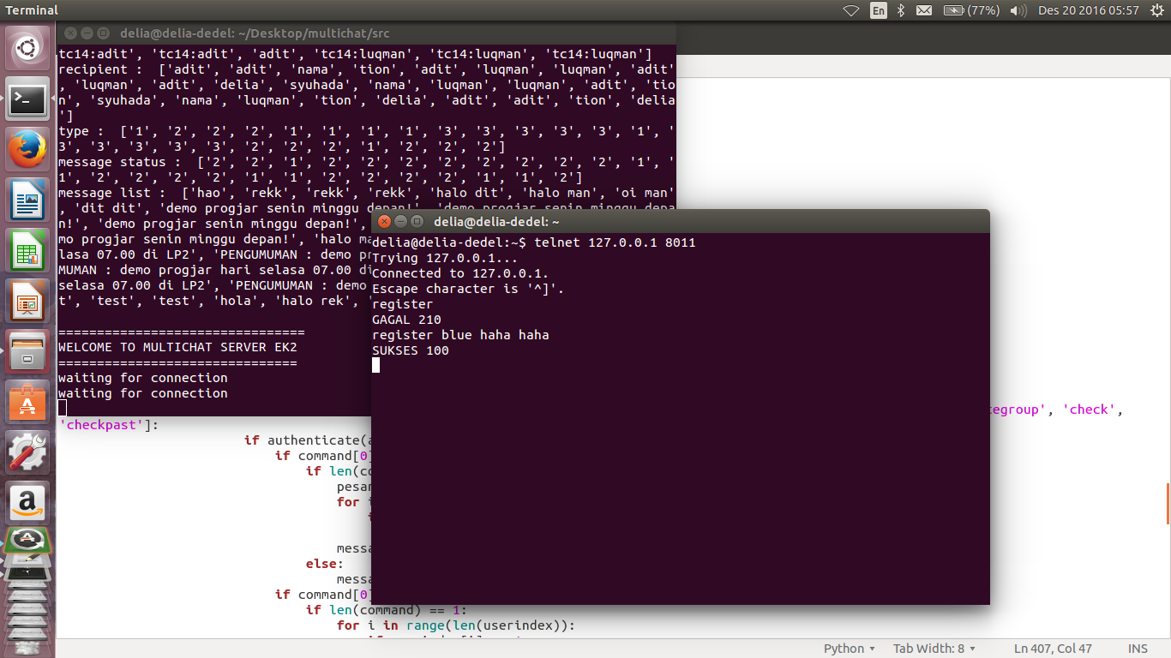

Gambar Login

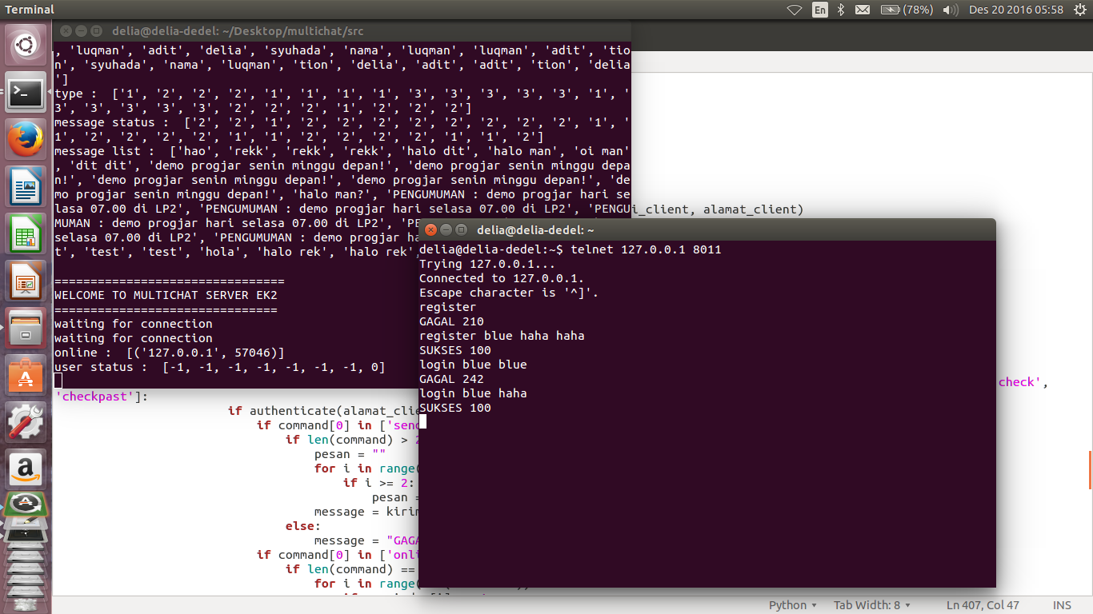

Gambar Private Message

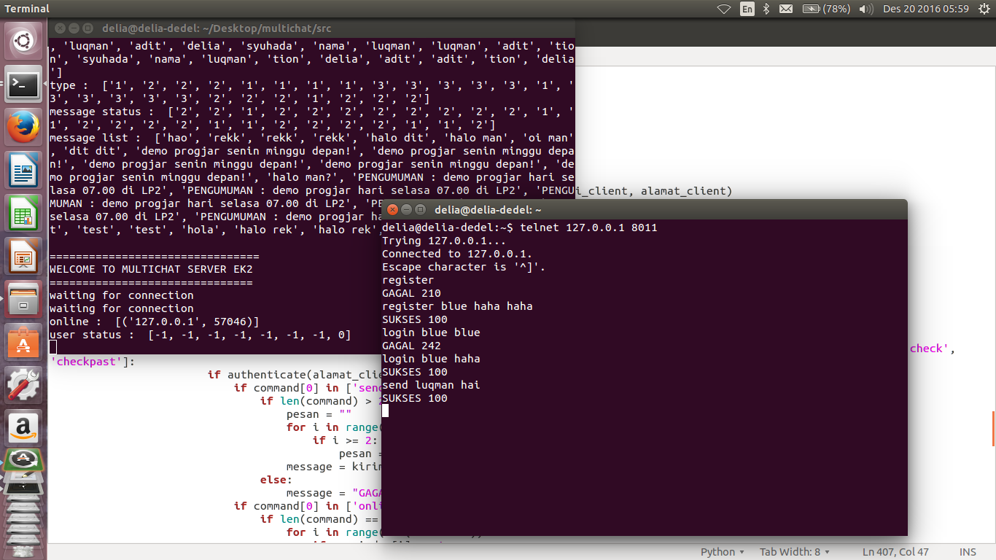

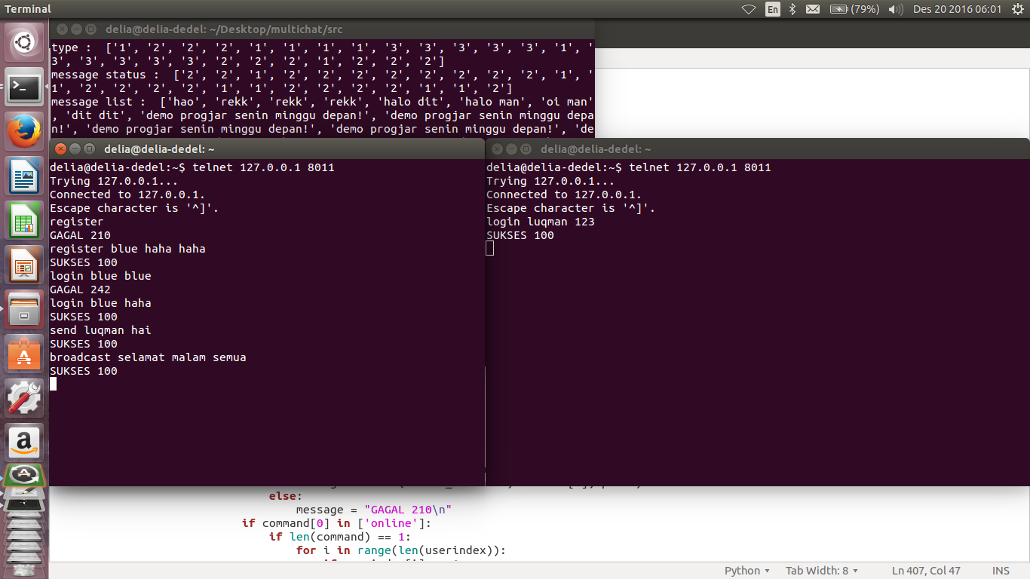

Gambar Broadcast Message

Gambar Check pesan belum terbaca

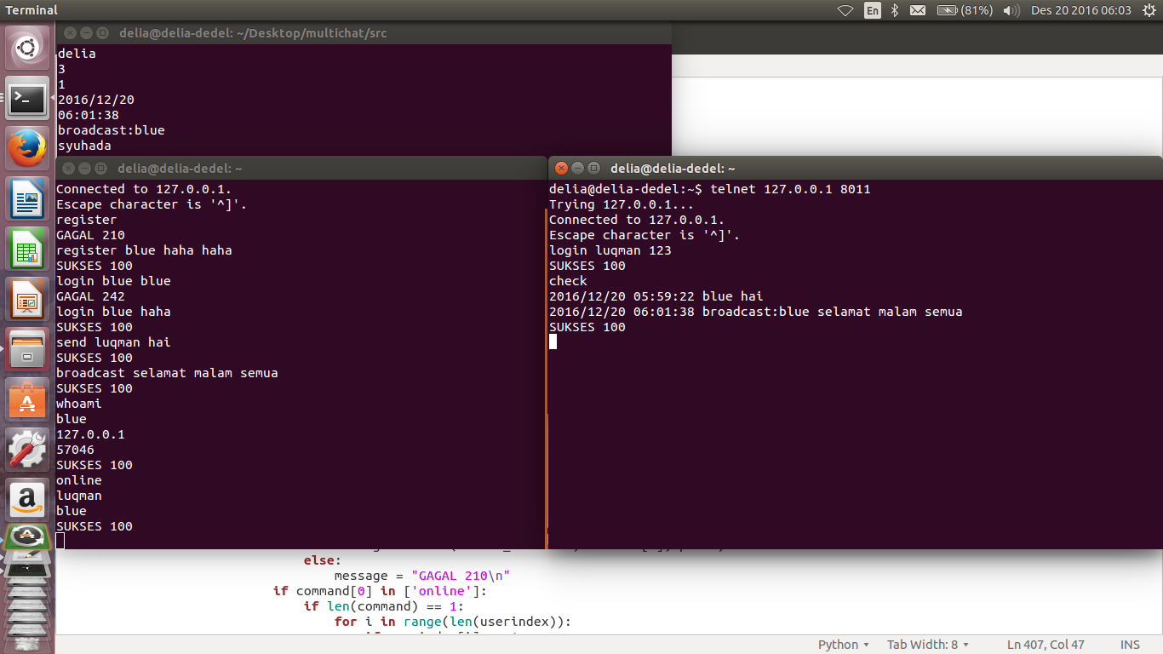

Gambar Checkpast (check message yang sudah terbaca)

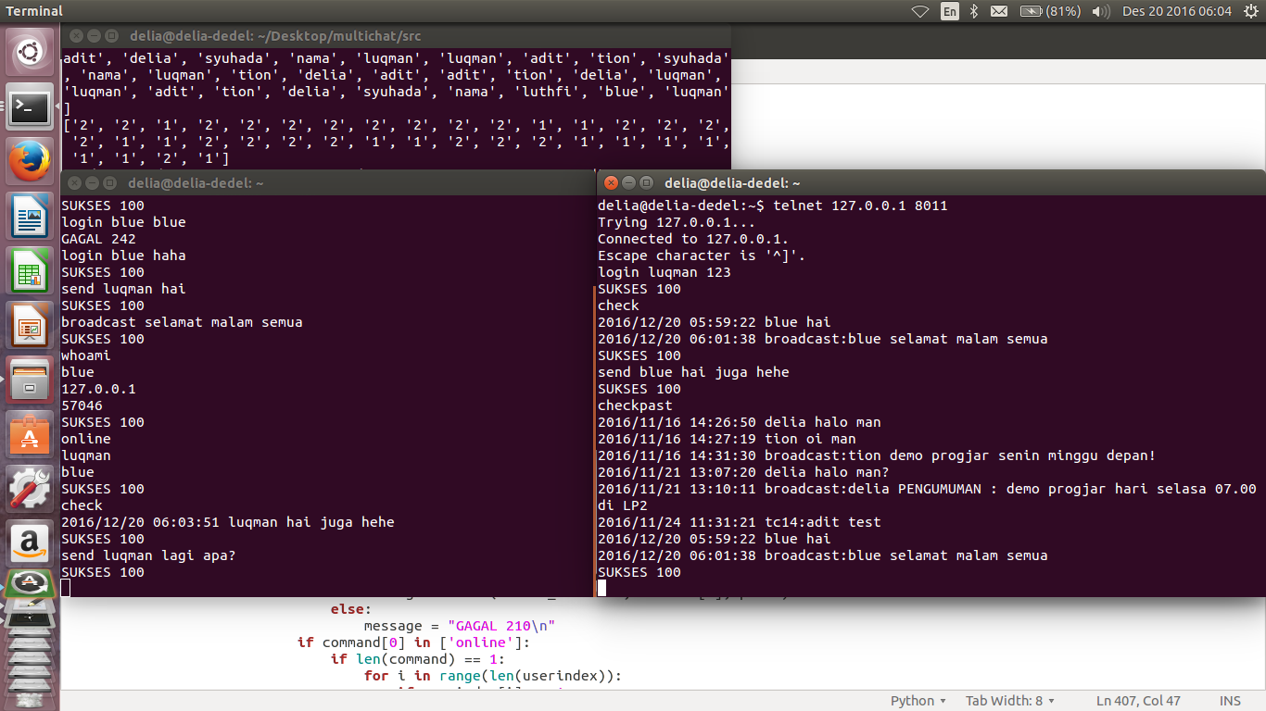

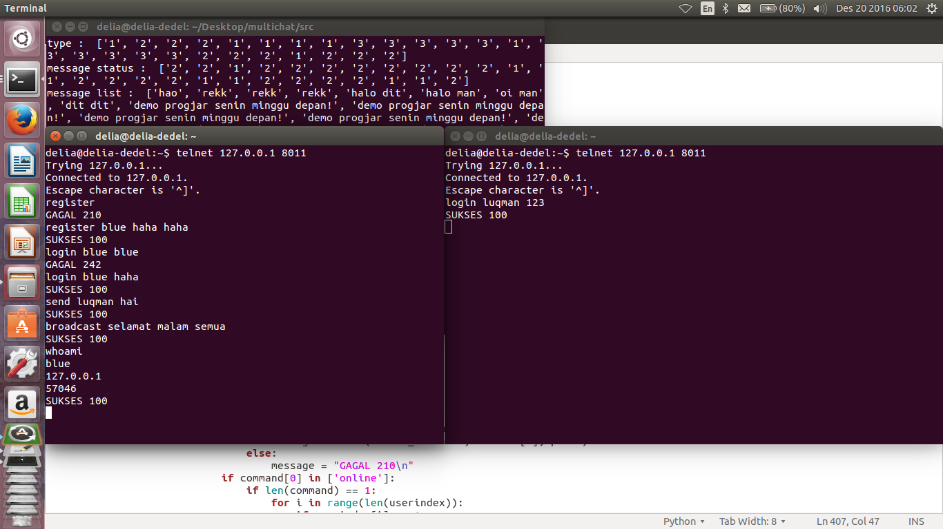

Gambar Whoami

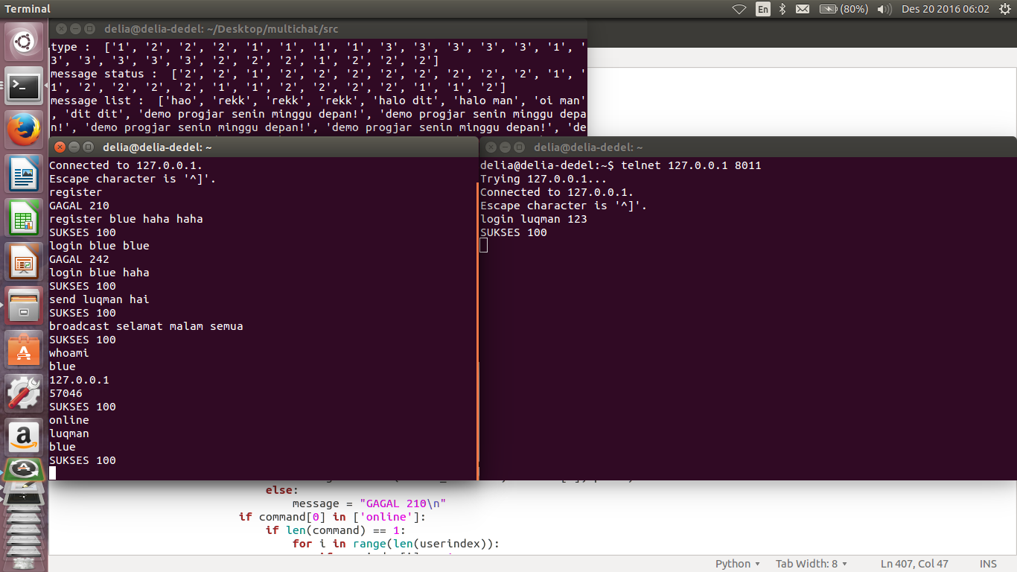

Gambar Online (cek teman yang online)

Gambar Create Group

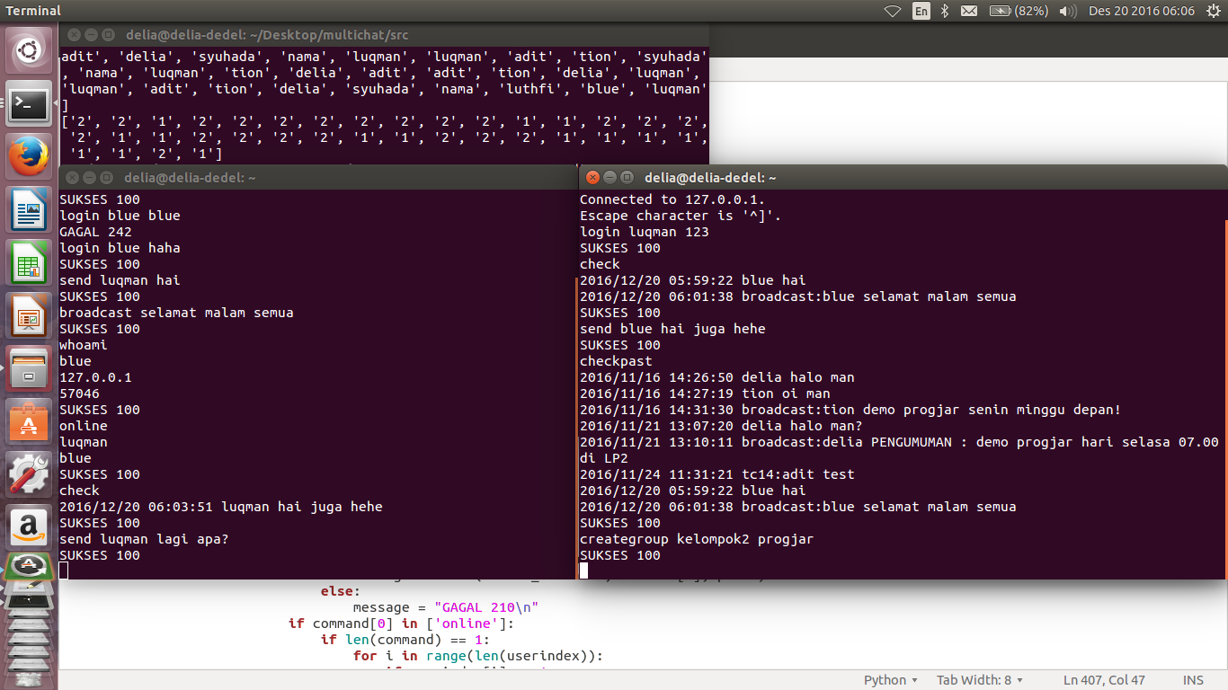

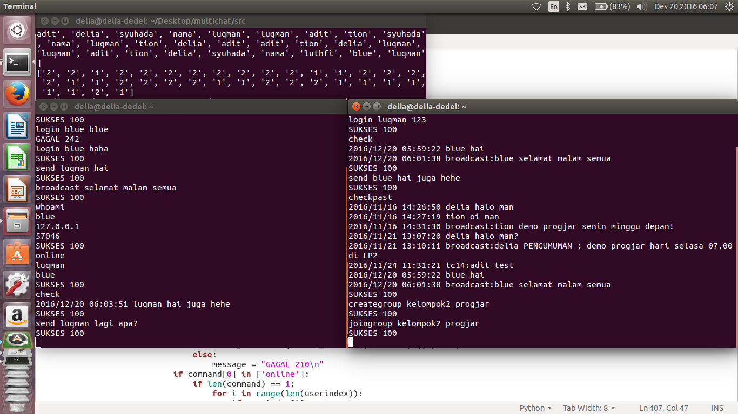

Gambar Join Group

Gambar Chat Group ( chat ke group)

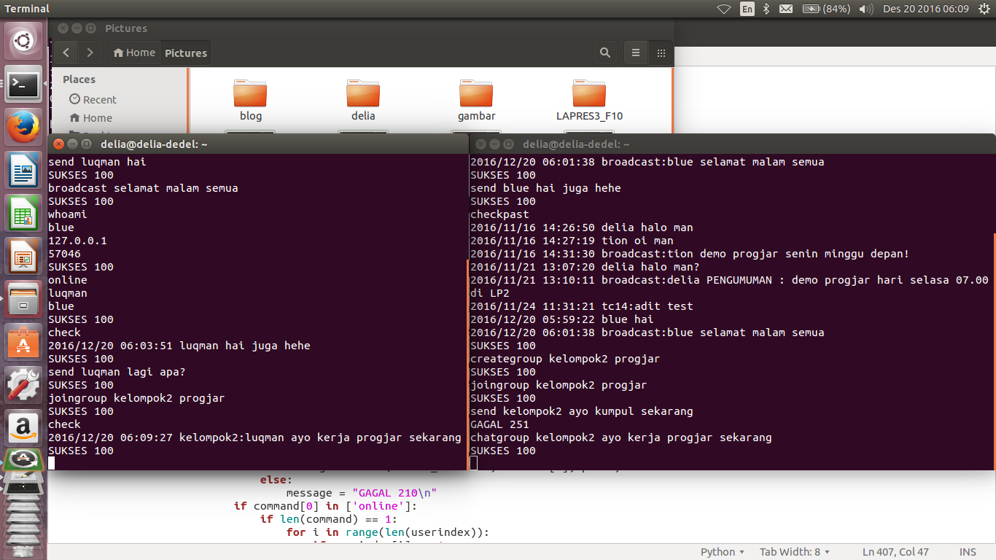

Gambar Logout

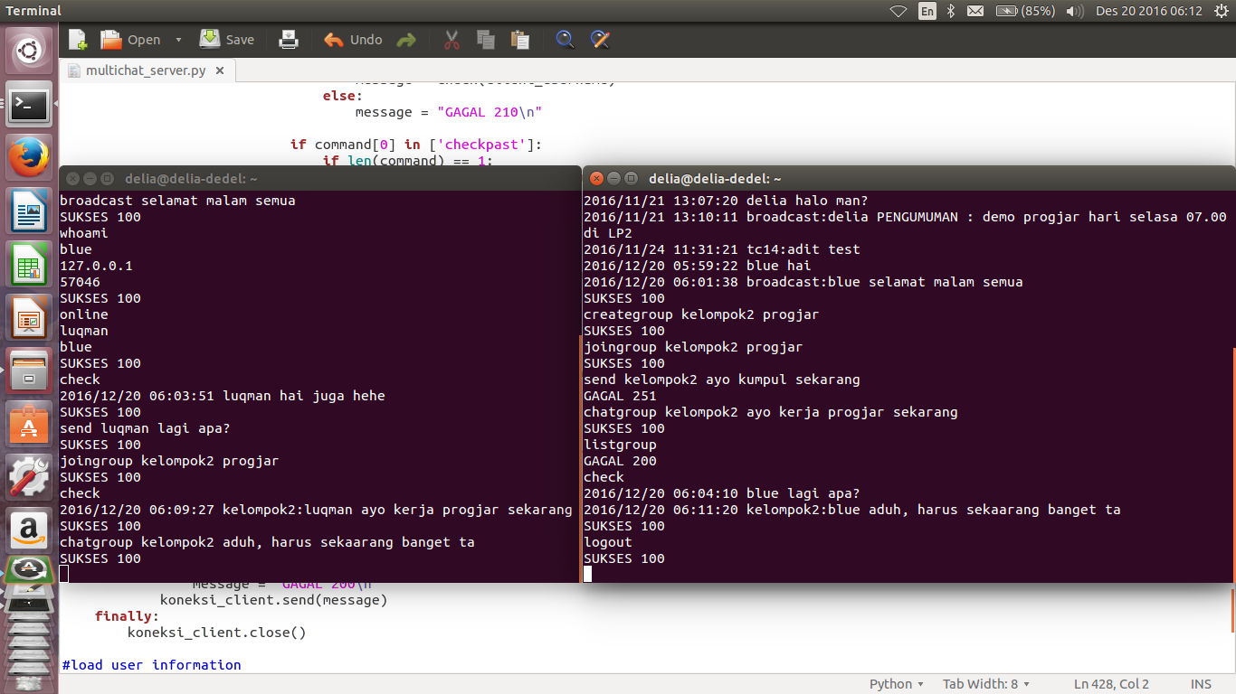

Gambar Exit

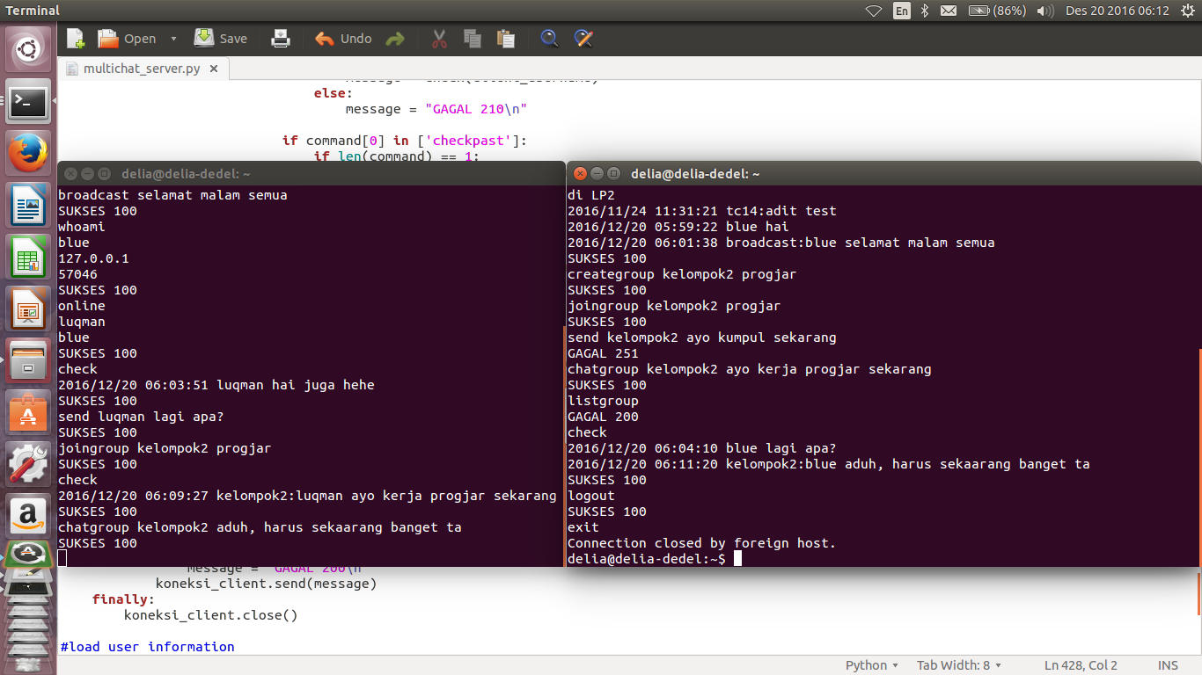

## PEMBAGIAN TUGAS

|  |  |  |  |
| --- | --- | --- | --- |
| **No** | **NRP** | **Nama** | **Tugas** |
| 1. | 5114100033 | Delia Risti N. | Membuat fitur register |
| Membuat fitur private message |
| Membuat fitur check ourself |
| 2. | 5114100053 | Tionia Rizkika | Membuat fitur login |
| Membuat fitur logout |
| Membuat fitur exit |
| 3. | 5114100167 | Aditya Gunawan | Membuat fitur check online friend |
| Membuat fitur check message |
| Membuat fitur checkpast |
| 4. | 5114100187 | Luqman Ahmad | Membuat fitur chat group |
| Membuat fitur create group |
| Membuat fitur join group |
| Membuat fitur broadcast message |

# Rancangan Client dari Server Kelompok lain

Client yang dibuat adalah client dari chat server milik kelompok 3. Client ini dilengkapi dengan GUI untuk memudahkan user dalam menggunakan client chat tersebut.

## FITUR

### Sign Up

Command :

**SIGNUP<spasi>USERNAME<spasi>PASSWORD**

Parameter :

USERNAME:alfanumerik, tanpa spasi

PASSWORD :alfanumerik, tanpa spasi

Return:

* + - 1111 :Sign Up berhasil
    - 1112 : Sign Up gagal karenausername sudah ada
    - 1113 : Sign Up gagal karena kesalahan format
    - 1111 REGIST [USERNAME] OK (untuk informasi di server)
    - 0001 : syntax error
    - 0003 : failed karena sudah login

### Login

Command :

**MASUK<spasi>USERNAME<spasi>PASSWORD**

Parameter :

USERNAME:alfanumerik (tanpa spasi)

PASSWORD :alfanumerik (tanpa spasi)

Return:

* + 2221 : Login sukses
  + 2222 : Login gagal karena username/password salah
  + 2221 LOGIN [USERNAME] OK (informasi dalam sisi server)
  + 0001 : syntax error
  + 0003 : Anda sudah login

### Chat Personal

Command :

**SEND<spasi>USERNAME_PENERIMA<spasi>MESSAGE**

Parameter :

USERNAME_PENERIMA:alfanumerik (tanpa spasi)

MESSAGE : pesan (256 character)

Return:

* + 3331 : Pesan personal terkirim
  + 3331 SENDP [USERNAME] OK (tampilan dalam sisi server)
  + 3332 : Gagal karena username penerima tidak ada
  + 3333 : Gagal karena username sedang tidak online
  + 3334 : Gagal karena message kosong
  + 0001 :Command salah!
  + 0002 : Anda belum login!

### Buat Group

Command :

**BUATG<spasi>NAMA_GROUP**

Parameter :

NAMA_GROUP:alfanumerik (tanpa spasi)

Return :

* + 4441 : grup berhasil dibuat
  + 4441 [GROUP] BY [USERNAME] CREATED (tampilan dalam sisi server)
  + 4442 : gagal karena nama group sudah ada
  + 4443 : gagal karena kesalahan format parameter
  + 0001 : command salah
  + 0002 : anda belum login

### Gabung Group

Command :

**JOING<spasi>NAMA_GROUP**

Parameter :

NAMA_GROUP:alfanumerik (tanpa spasi)

Return :

* + 5551 : berhasil gabung group
  + 5551 [USERNAME] JOIN [GROUP] (informasi di tampilan server)
  + 5552 : gagal karena group tidak ada
  + 5553 : gagal join karena sudah join grup yang dituju
  + 0001 : command salah
  + 0002 : anda belum login

### Leave Group

Command :

**KELUAR<spasi>NAMA_GROUP**

Parameter :

NAMA_GROUP:alfanumerik (tanpa spasi)

Return :

* + 6661 : berhasil keluar group
  + 6661 [USERNAME] LEAVE [GROUP] (tampilan dalam sisi server)
  + 6662 : gagal karena anda belum masuk group
  + 6663 : gagal karena group tidak ada
  + 0001 : command salah
  + 0002 : anda belum login

### Chat Group

Command :

**SENDG<spasi>NAMA_GROUP<spasi>MESSAGE**

Parameter :

NAMA_GROUP:alfanumerik (tanpa spasi)

MESSAGE : pesan (256 character)

Return :

* + 7771 : SENDG OK pesan terkirim
  + 7771 [NAMAGRUP] [PENGIRIM] OK
  + 7772 : SENDG FAILED group tidak ada
  + 7773 : SENDG FAILED message kosong
  + 7774 : SENDG FAILED user belum tergabung
  + 0001 : FAILED command salah
  + 0002 : FAILED anda belum login

### Daftar User yang Aktif

Command :

**DAFTARUS**

Return :

* + 0003 : menampilkan daftar user yang sedang aktif
  + 0001 : command salah
  + 0002 : anda belum login

### Daftar Group yang Ada

Command :

**DAFTARGR**

Return :

* + 0004 : Menampilkan list group yang ada
  + 0001 : Command salah
  + 0002 : Anda belum login!

### Logout

Command :

**LOGOUT**

Return :

* + 2223 : berhasil logout
  + 2223 [USERNAME] LOGOUT (tampilan dalam sisi server)
  + 0001 : command salah
  + 0002 : belum login

## SOURCE CODE

from Tkinter import *

import socket

import sys

import tkMessageBox

import ttk

import threading

client_socket = socket.socket(socket.AF_INET, socket.SOCK_STREAM)

global_username = ""

def onClose(master):

message = "logout"

client_socket.sendall(message)

data = client_socket.recv(1024)

data = data.strip().split()

master.destroy()

print >>sys.stderr, 'onCLose'

return 1

def controlClose(master):

result = tkMessageBox.askquestion("Close", "Are You Sure?", icon='warning')

if result == 'yes':

onClose(master)

else:

return 0

#send message

message = "SEND "+recipient+" "+msg

client_socket.sendall(message)

widget.insert(END, "You say : "+msg+"\n")

widget.see("end")

return 1

def closeRoom(master, thread):

print "1"

master.destroy()

client_socket.sendall("DUMP")

print "2"

return 1

def sendGroup(master, groupname):

#main frame

mainframe = master.winfo_children()

frames = mainframe[0].winfo_children()

#get scrollbar widget

widget = frames[0].winfo_children()

scrollbar=widget[0]

#get text widget

widget=widget[1]

#get entry widget

entry = frames[1].winfo_children()

entry = entry[0]

#get message

msg = entry.get()

entry.delete(0, 'end')

#send message

message = "SENDG "+groupname+" "+msg

client_socket.sendall(message)

widget.insert(END, "You say : "+msg+"\n")

widget.see("end")

return 1

def recvGroup(textMessage, groupname, client_username):

while True:

print "on while recv message"

data = client_socket.recv(1024)

data = data.split("(")

print data

if data[0] == groupname:

message = data[1].split(")")

username = message[0]

print username

print client_username

if username == client_username:

continue

else:

message = message[1].split(":")

message = message[1].split("\n")

msg = message[0]

textMessage.insert(END, username+" say : "+msg+"\n")

textMessage.see("end")

print "1"

elif data[0] == "0001\n":

print "2"

break

elif data[0] == "3331\n":

continue

else:

continue

print "thread destroyed : "+groupname

return 1

textMessage.insert(END, username+" say : "+msg+"\n")

textMessage.see("end")

print "1"

elif data[0] == "0001\n":

print "2"

break

elif data[0] == "3331\n":

continue

else:

continue

print "thread destroyed : "+groupname

return 1

def showGroup(event, username):

widget = event.widget

print "username : "+username

selection = widget.curselection()

groupname = widget.get(selection[0])

print groupname

#join grup sebelum melakukan chat dengan group

respon = tkMessageBox.askquestion("Join Group", "You will automatically join the group. Are you sure?")

if respon == 'no':

return 0

message = "JOING "+groupname

client_socket.sendall(message)

data = client_socket.recv(1024)

top = Tk()

top.title(groupname)

mainframe = Frame(top, bd=10)

mainframe.pack()

frameMessage = Frame(mainframe, bd = 5)

frameMessage.pack()

frameInput = Frame(mainframe, bd = 5)

frameInput.pack()

scrollbar = Scrollbar(frameMessage)

scrollbar.pack(side=RIGHT, fill=Y)

textMessage = Text(frameMessage, yscrollcommand=scrollbar.set, width=40, height=20)

textMessage.pack()

scrollbar.config(command=textMessage.yview)

s = threading.Thread(target=recvGroup, args=(textMessage, groupname, username))

s.start()

entry = Entry(frameInput, width=30)

entry.pack(side=LEFT)

buttonSend = Button(frameInput, text="Send", command= lambda:sendGroup(top, groupname))

buttonSend.pack(side=LEFT)

top.protocol("WM_DELETE_WINDOW", lambda: closeRoom(top, s))

top.mainloop()

return 1

def showRoom(event):

widget = event.widget

selection = widget.curselection()

username = widget.get(selection[0])

print username

top = Tk()

top.title(username)

mainframe = Frame(top, bd=10)

mainframe.pack()

frameMessage = Frame(mainframe, bd = 5)

frameMessage.pack()

frameInput = Frame(mainframe, bd = 5)

frameInput.pack()

scrollbar = Scrollbar(frameMessage)

scrollbar.pack(side=RIGHT, fill=Y)

textMessage = Text(frameMessage, yscrollcommand=scrollbar.set, width=40, height=20)

textMessage.pack()

scrollbar.config(command=textMessage.yview)

s = threading.Thread(target=recvMessage, args=(textMessage, username))

s.start()

entry = Entry(frameInput, width=30)

entry.pack(side=LEFT)

buttonSend = Button(frameInput, text="Send", command= lambda:sendMessage(top, username))

buttonSend.pack(side=LEFT)

top.protocol("WM_DELETE_WINDOW", lambda: closeRoom(top, s))

top.mainloop()

return 1

def onCreateGroup(master, groupname):

message = "BUATG "+groupname

client_socket.sendall(message)

data = client_socket.recv(1024)

data = data.split()

if data[0] in ['4441']:

respon = tkMessageBox.showinfo("Berhasil", "Group berhasil dibuat, Ok utk melanjutkan")

if respon == 'ok':

master.destroy()

elif data[0] in ['4442']:

respon = tkMessageBox.showinfo("Gagal", "Nama group telah terpakai")

return 1

def controlCreateGroup(master):

top = Tk()

top.title("Create Group")

mainframe = Frame(top, bd=10)

mainframe.pack()

entryName = Entry(mainframe, width=20)

entryName.pack()

buttonCreate = Button(mainframe, text="Create", command=lambda:onCreateGroup(top, entryName.get()))

buttonCreate.pack()

return 1

def showDashboard(username):

top = Tk()

top.title("Dashboard Chat-EK2")

top.protocol("WM_DELETE_WINDOW", lambda:controlClose(top))

#border luar

topframe = Frame(top, bd=10)

topframe.pack()

#notebook

notebook = ttk.Notebook(topframe)

#notebook page 1

mainframe = Frame(notebook, bd = 10)

mainframe.pack()

labelFrame = LabelFrame(mainframe, text="Basic Info", font=("Calibri", 9), width=20)

labelFrame.pack()

frameUser = Frame(labelFrame, bd=5)

frameUser.pack()

labelUser = Label(frameUser, text="Login as")

labelUser.pack(side=LEFT)

infoUser = Label(frameUser, text=": "+username)

infoUser.pack(side=LEFT)

frameLabelList = Frame(mainframe, bd = 5)

frameLabelList.pack()

frameListUser = Frame(mainframe, bd=5)

frameListUser.pack()

labelListUser = Label(frameLabelList, text="Online User :")

labelListUser.pack(side = LEFT)

scrollbar = Scrollbar(frameListUser)

scrollbar.pack( side = RIGHT, fill=Y)

listboxUser = Listbox(frameListUser, yscrollcommand = scrollbar.set, height=5, width=20)

listboxUser.bind('<<ListboxSelect>>', showRoom)

buttonRefresh = Button(frameLabelList, text="Refresh", command=lambda:initListUser(listboxUser) )

buttonRefresh.pack(side = LEFT)

initListUser(listboxUser)

listboxUser.pack()

scrollbar.config(command = listboxUser.yview)

notebook.add(mainframe, text="Private")

#notebook page 2

mainframe = Frame(notebook, bd = 10)

mainframe.pack()

labelFrame = LabelFrame(mainframe, text="Basic Info", font=("Calibri", 9), width=20)

labelFrame.pack()

frameUser = Frame(labelFrame, bd=5)

frameUser.pack()

labelUser = Label(frameUser, text="Login as")

labelUser.pack(side=LEFT)

infoUser = Label(frameUser, text=": "+username)

infoUser.pack(side=LEFT)

frameLabelList = Frame(mainframe, bd = 5)

frameLabelList.pack()

frameListUser = Frame(mainframe, bd=5)

frameListUser.pack()

labelListUser = Label(frameLabelList, text="Group List :")

labelListUser.pack(side=LEFT)

scrollbar = Scrollbar(frameListUser)

scrollbar.pack( side = RIGHT, fill=Y)

listboxGroup = Listbox(frameListUser, yscrollcommand = scrollbar.set, height=5, width=20)

listboxGroup.bind('<<ListboxSelect>>', lambda event: showGroup(event, username))

buttonRefresh = Button(frameLabelList, text="Refresh", command=lambda:initListGroup(listboxGroup) )

buttonRefresh.pack(side = LEFT)

initListGroup(listboxGroup)

listboxGroup.pack()

scrollbar.config(command = listboxGroup.yview)

buttonCreate = Button(mainframe, text="Create Group", command=lambda:controlCreateGroup(top))

buttonCreate.pack()

notebook.add(mainframe, text="Group")

notebook.pack()

top.mainloop()

scrollbar = Scrollbar(frameListUser)

scrollbar.pack( side = RIGHT, fill=Y)

listboxGroup = Listbox(frameListUser, yscrollcommand = scrollbar.set, height=5, width=20)

listboxGroup.bind('<<ListboxSelect>>', lambda event: showGroup(event, username))

buttonRefresh = Button(frameLabelList, text="Refresh", command=lambda:initListGroup(listboxGroup) )

buttonRefresh.pack(side = LEFT)

initListGroup(listboxGroup)

listboxGroup.pack()

scrollbar.config(command = listboxGroup.yview)

buttonCreate = Button(mainframe, text="Create Group", command=lambda:controlCreateGroup(top))

buttonCreate.pack()

notebook.add(mainframe, text="Group")

notebook.pack()

top.mainloop()

def controlLogin(master):

mainframe = master.winfo_children()

frames = mainframe[0].winfo_children()

widgets = frames[0].winfo_children()

username = widgets[1].get()

widgets = frames[1].winfo_children()

password = widgets[1].get()

print >>sys.stderr, 'message: '+username

print >>sys.stderr, 'password: '+password

message = 'MASUK '+username+' '+password

client_socket.sendall(message)

data = client_socket.recv(1024)

data = data.strip().split()

if data[0] in ['2221']:

master.destroy()

global_username = username

showDashboard(username)

elif data[0] in ['2222']:

tkMessageBox.showinfo("Error", "Username atau password salah")

elif data[0] in ['0003']:

tkMessageBox.showinfo("Error", "Akun \""+username+"\" sedang login")

return 1

def controlRegister(master):

mainframe = master.winfo_children()

frames = mainframe[0].winfo_children()

widgets = frames[0].winfo_children()

username = widgets[1].get()

widgets = frames[1].winfo_children()

password = widgets[1].get()

widgets = frames[2].winfo_children()

repassword = widgets[1].get()

print >>sys.stderr, 'message: '+username

print >>sys.stderr, 'password: '+password

print >>sys.stderr, 'repass: '+password

if password == repassword:

message = "SIGNUP "+username+" "+password

client_socket.sendall(message)

data = client_socket.recv(1024)

data = data.strip().split()

if data[0] in ['1111']:

respon = tkMessageBox.showinfo("Berhasil", "Registrasi akun berhasil")

if respon == 'ok':

showHome(master)

else:

print "not oke"

elif data[0] in ['1112']:

tkMessageBox.showinfo("Error", "Username sudah ada")

else:

tkMessageBox.showinfo("Error", "Unknown error")

else:

tkMessageBox.showinfo("Registrasi", "Password tidak cocok")

return 1

def showRegister(master):

master.destroy()

top = Tk()

top.title("Registration")

top.protocol("WM_DELETE_WINDOW", lambda: controlClose(top))

mainframe = Frame(top, bd = 10)

mainframe.pack()

frame = Frame(mainframe, bd = 5)

frame.pack()

frameBottom = Frame(mainframe, bd = 5)

frameBottom.pack(side = TOP)

frameBottom2 = Frame(mainframe, bd = 5)

frameBottom2.pack(side = TOP)

frameButton = Frame(mainframe, bd = 5)

frameButton.pack(side = TOP)

L1 = Label(frame, text="User Name", width=10)

L1.pack( side = LEFT)

E1 = Entry(frame, bd =2)

E1.pack(side = LEFT)

L2 = Label(frameBottom, text="Password", width=10)

L2.pack( side = LEFT)

E2 = Entry(frameBottom, bd =2)

E2.pack(side = LEFT)

L3 = Label(frameBottom2, text="Retype Pass", width = 10)

L3.pack(side=LEFT)

E3 = Entry(frameBottom2, bd =2)

E3.pack(side = LEFT)

buttonRegister = Button(frameButton, text=("Register"), font=("Calibri", 9), command=lambda: controlRegister(top))

buttonRegister.pack(side=LEFT)

buttonCancel = Button(frameButton, text=("Cancel"), font=("Calibri", 9), command=lambda: showHome(top))

buttonCancel.pack(side=LEFT)

top.mainloop()

def showLogin(master):

master.destroy()

top = Tk()

top.title("Login")

top.protocol("WM_DELETE_WINDOW", lambda: controlClose(top))

mainframe = Frame(top, bd = 10)

mainframe.pack()

frame = Frame(mainframe, bd = 5)

frame.pack()

frameBottom = Frame(mainframe, bd = 5)

frameBottom.pack(side = TOP)

frameButton = Frame(mainframe, bd = 5)

frameButton.pack(side = TOP)

L1 = Label(frame, text="User Name", width=10)

L1.pack( side = LEFT)

E1 = Entry(frame, bd =2)

E1.pack(side = LEFT)

L2 = Label(frameBottom, text="Password", width=10)

L2.pack( side = LEFT)

E2 = Entry(frameBottom, bd =2)

E2.pack(side = LEFT)

buttonLogin = Button(frameButton, text=("Login"), font=("Calibri", 9), command=lambda: controlLogin(top))

buttonLogin.pack(side=LEFT)

buttonCancel = Button(frameButton, text=("Cancel"), font=("Calibri", 9), command=lambda: showHome(top))

buttonCancel.pack(side=LEFT)

top.mainloop()

def showHome(master):

master.destroy()

top = Tk()

top.title("Chat EK-2")

top.minsize(200, 150)

top.maxsize(200, 150)

#top.protocol("WM_DELETE_WINDOW", onClose)

frameFill = Frame(top, height=30)

frameFill.pack()

frameLogin = Frame(top)

frameLogin.pack()

frameRegister = Frame(top)

frameRegister.pack(side = TOP)

loginButton = Button(frameLogin, text="Login", width=10, height=2, font=("Calibri", 9), command=lambda: showLogin(top))

loginButton.pack(side = TOP)

registerButton = Button(frameRegister, text="Register", width=10, height=2,font=("Calibri", 9), command=lambda: showRegister(top))

registerButton.pack(side = TOP)

top.mainloop()

def controlConnect(master):

mainframes = master.winfo_children()

frames = mainframes[0].winfo_children()

widgets = frames[0].winfo_children()

address = widgets[1].get()

widgets = frames[1].winfo_children()

port = widgets[1].get()

print "parameter : "+address+" "+port

try:

server_address = (address, int(port))

client_socket.connect(server_address)

print "koneksi sukses"

showHome(master)

except:

print "koneksi gagal"

tkMessageBox.showinfo("Info", "Connection error!")

def initialize():

top = Tk()

top.title("Chat EK-2")

frame = Frame(top, bd=5)

frame.pack()

frameServerAddress = Frame(frame, bd=5)

frameServerAddress.pack()

frameServerPort = Frame(frame, bd=5)

frameServerPort.pack(side = TOP)

frameButton = Frame(frame, bd=5)

frameButton.pack(side=TOP)

labelAddress = Label(frameServerAddress, text=("Server Address"), width = 15, justify=LEFT)

labelAddress.pack(side=LEFT)

labelPort = Label(frameServerPort, text=("Server Port"), width = 15, justify=LEFT)

labelPort.pack(side=LEFT)

entryAddress = Entry(frameServerAddress, bd=2)

entryAddress.pack(side=LEFT)

entryPort = Entry(frameServerPort, bd=2)

entryPort.pack(side=LEFT)

buttonConnect = Button(frameButton, text=("Connect"), command=lambda: controlConnect(top))

buttonConnect.pack(side=TOP)

top.mainloop()

initialize()

'''

Note:

1. fungsi tidak di return sebelum fungsi lain di return

'''

## SCREENSHOT CLIENT

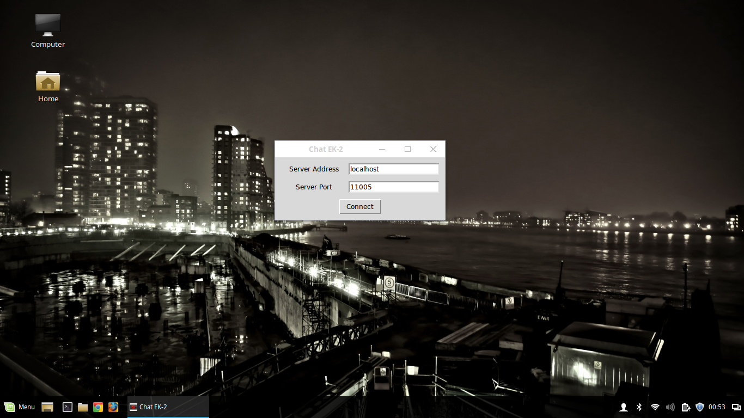

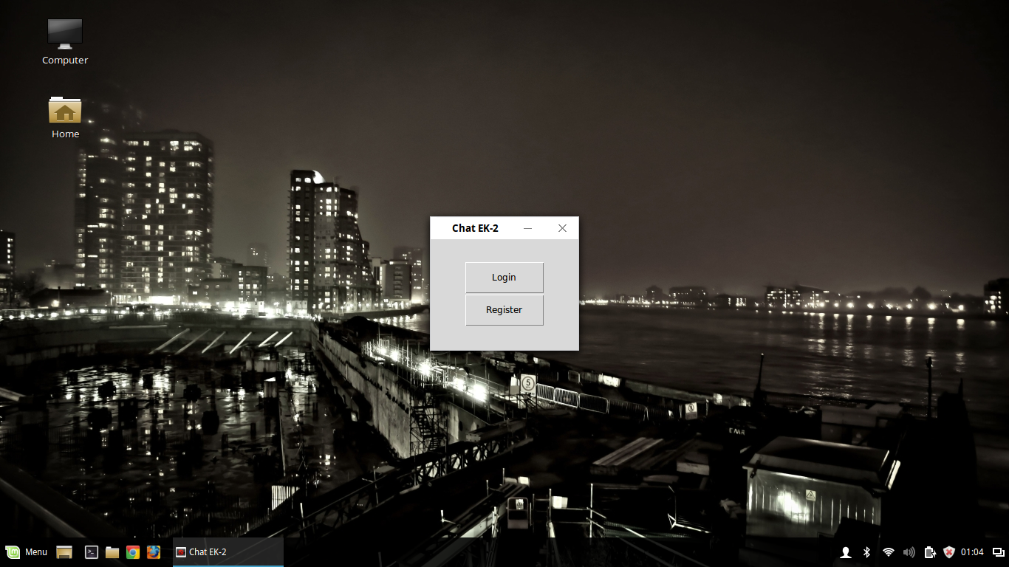

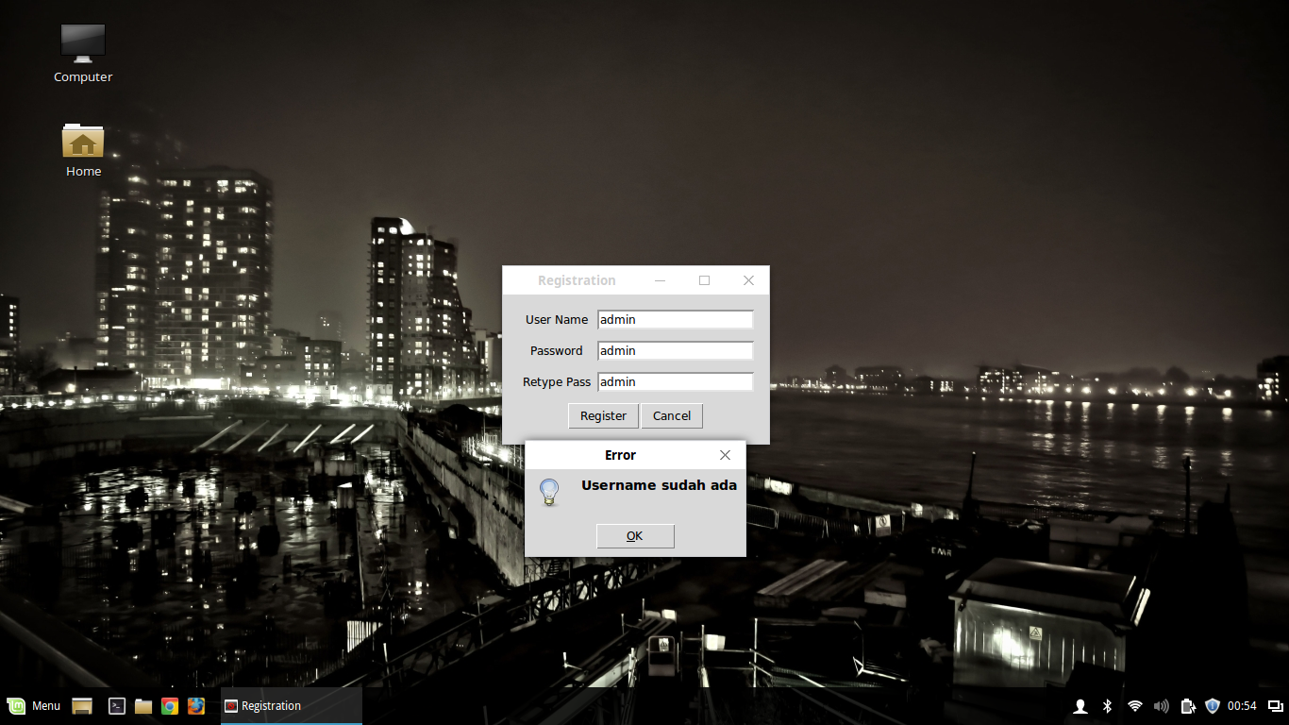

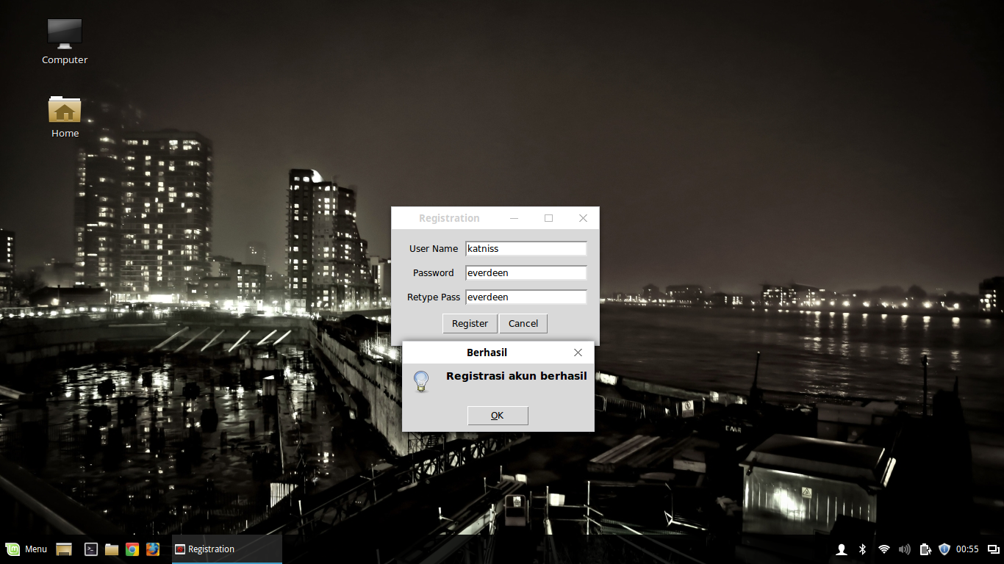

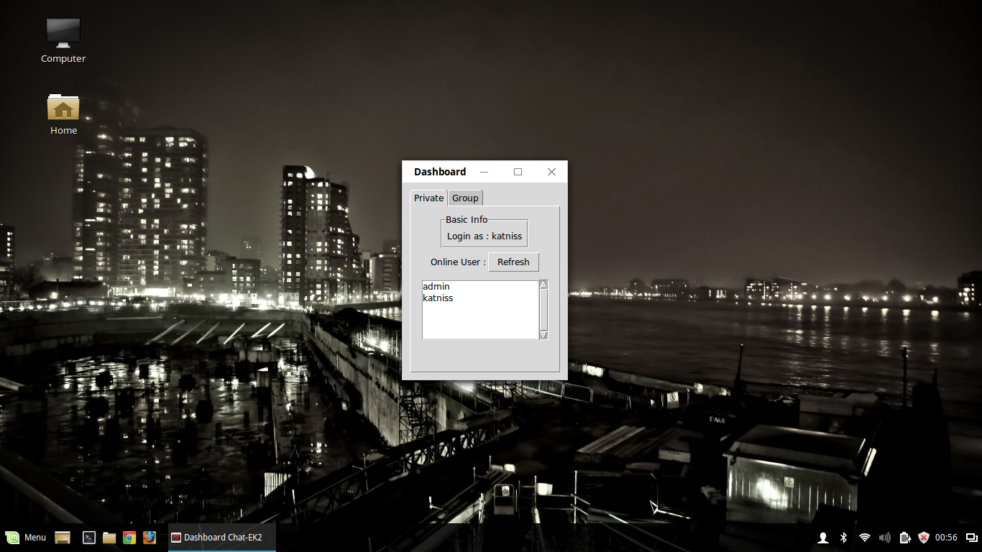

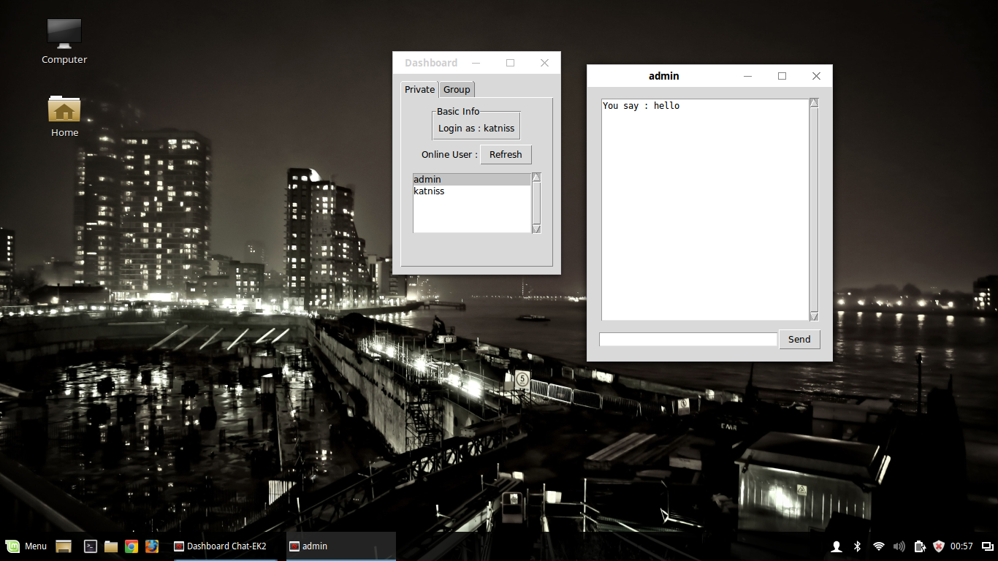

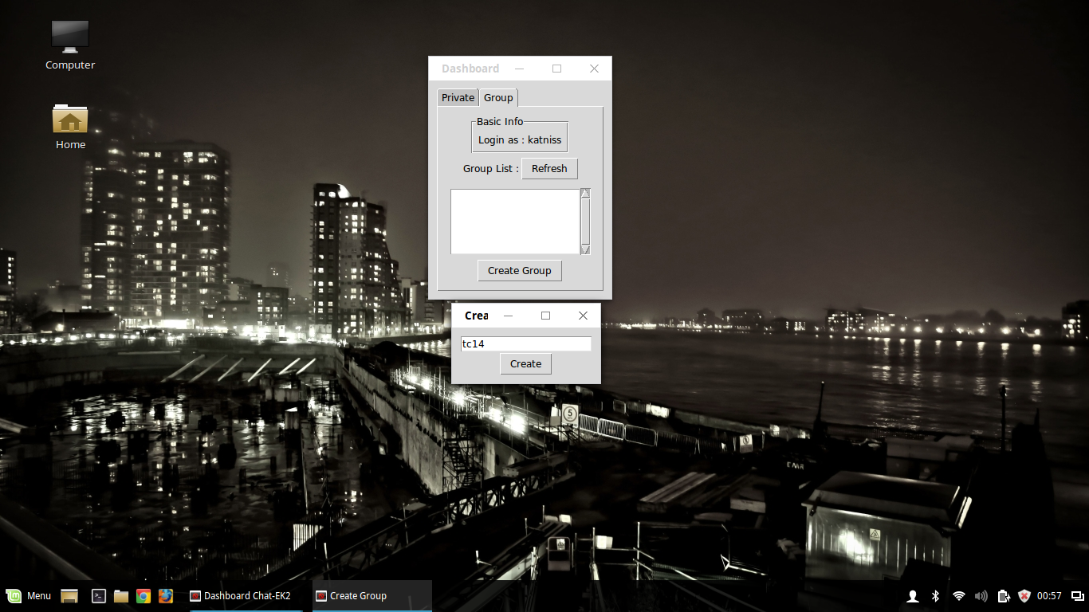

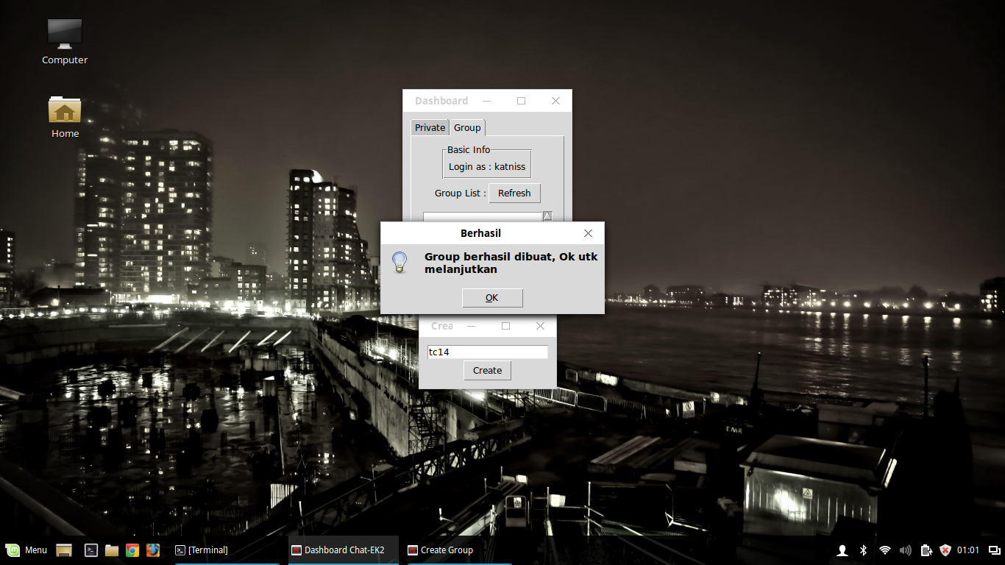

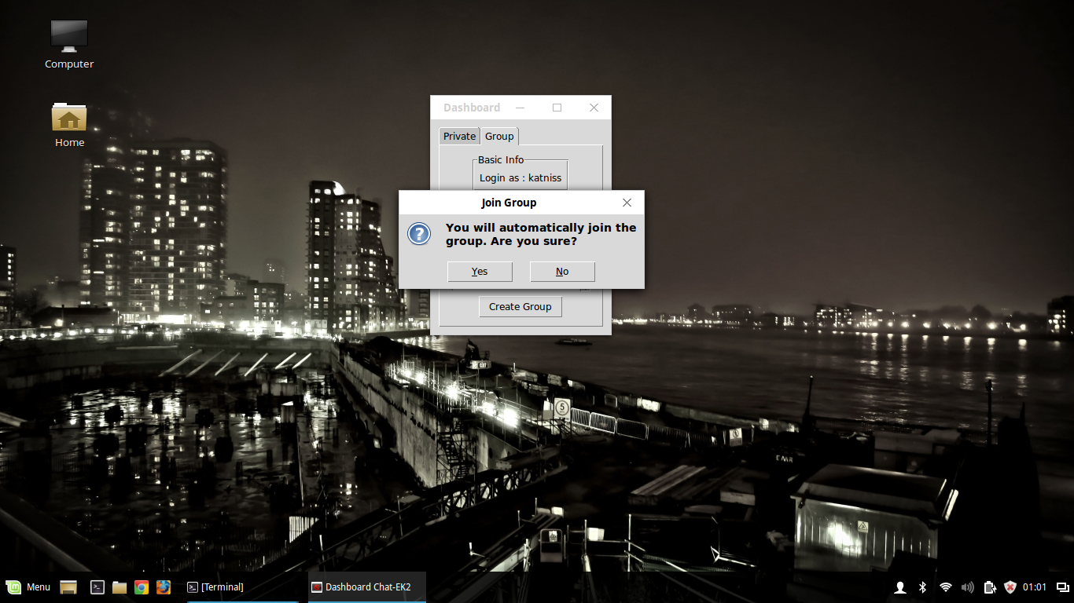

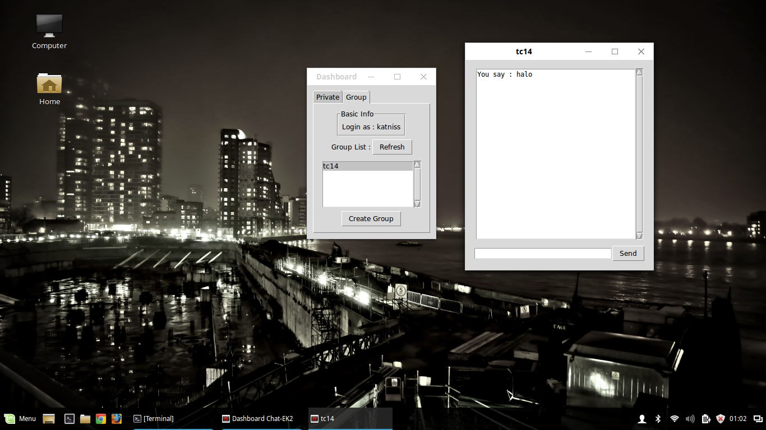

## PEMBAGIAN TUGAS

|  |  |  |  |
| --- | --- | --- | --- |
| **No** | **NRP** | **Nama** | **Tugas** |
| 1. | 5114100033 | Delia Risti N. | Membuat fitur sign up |
| Membuat fitur leave group |
| 2. | 5114100053 | Tionia Rizkika | Membuat fitur login |
| Membuat fitur logout |
| 3. | 5114100167 | Aditya Gunawan | Membuat fitur daftar user yang sedang aktif |
| Membuat fitur daftar grup yang ada |
| 4. | 5114100187 | Luqman Ahmad | Membuat fitur chat personal |
| Membuat fitur buat group |
| Membuat fitur gabung group |
| Membuat fitur chat group |